**SOFTWARE REQUIREMENTS SPECIFICATION**

**For**

**JOB PORTAL SYSTEM**

**Prepared by:**

LEELA VINOTHAN A

MITHUN VIJAY V M

KARTHIKEYAN R

**1. Introduction:**

**1.1 purpose**

A job portal system serves as an online platform that connects job seekers with employers.The purpose of a job portal system is multifaceted and involves facilitating the entire job search and recruitment process. Job portals allow individuals to search for job opportunities based on their skills, qualifications, and preferences. They provide a centralized platform where job seekers can explore a wide range of job openings across various industries and locations. Companies can post job vacancies, making them visible to a large pool of potential candidates.

**1.2 Document Conventions**

➣Entire document should be justified.

➣Convention for Main title

𑇐 Font face: Arial

𑇐 Font style: Bold

𑇐 Font Size: 36

➣Convention for Sub title

𑇐 Font face: Times New Roman

𑇐 Font style: Bold

𑇐 Font Size: 14

➣Convention for body

𑇐 Font face: Times New Roman

𑇐 Font Size: 14

**1.3 Scope Of Development Project :**

The development of a job portal system holds significant scope in the contemporary job market. With the increasing reliance on digital platforms for recruitment, the project aims to provide a streamlined and efficient solution for both job seekers and employers. The system's scope includes user-friendly interfaces for creating and updating profiles, advanced search algorithms for personalized job recommendations, and seamless communication channels. The development project also encompasses the creation of a robust resume database, facilitating quick and targeted candidate searches. The platform's accessibility from anywhere with an internet connection broadens its reach, fostering diverse talent acquisition for employers. Incorporating analytics tools enhances the project's value by providing valuable insights for employers to optimize their recruitment strategies. Additionally, the inclusion of career development resources adds a comprehensive dimension, making the job portal system a one-stop solution for individuals navigating the dynamic landscape of employment opportunities.

**1.4 Definitions, Acronyms and Abbreviations :**

JAVA -> platform independence

SQL-> Structured query Language

ER-> Entity Relationship

UML -> Unified Modeling Language

IDE-> Integrated Development Environment

SRS-> Software Requirement Specification

**1.5 References**

➣ Books

JOB SEARCH PORTAL BY SOWMYA MUTHKUMALLI

JOB PORTAL SYSTEM BY KRISHNA KUMAR RANJAN

**2. Overall Descriptions**

2.1 Product Perspective :

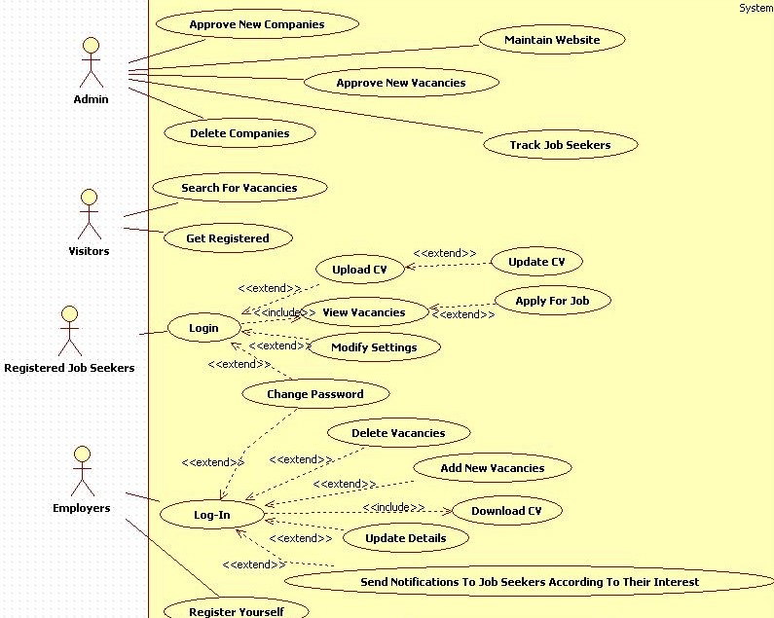

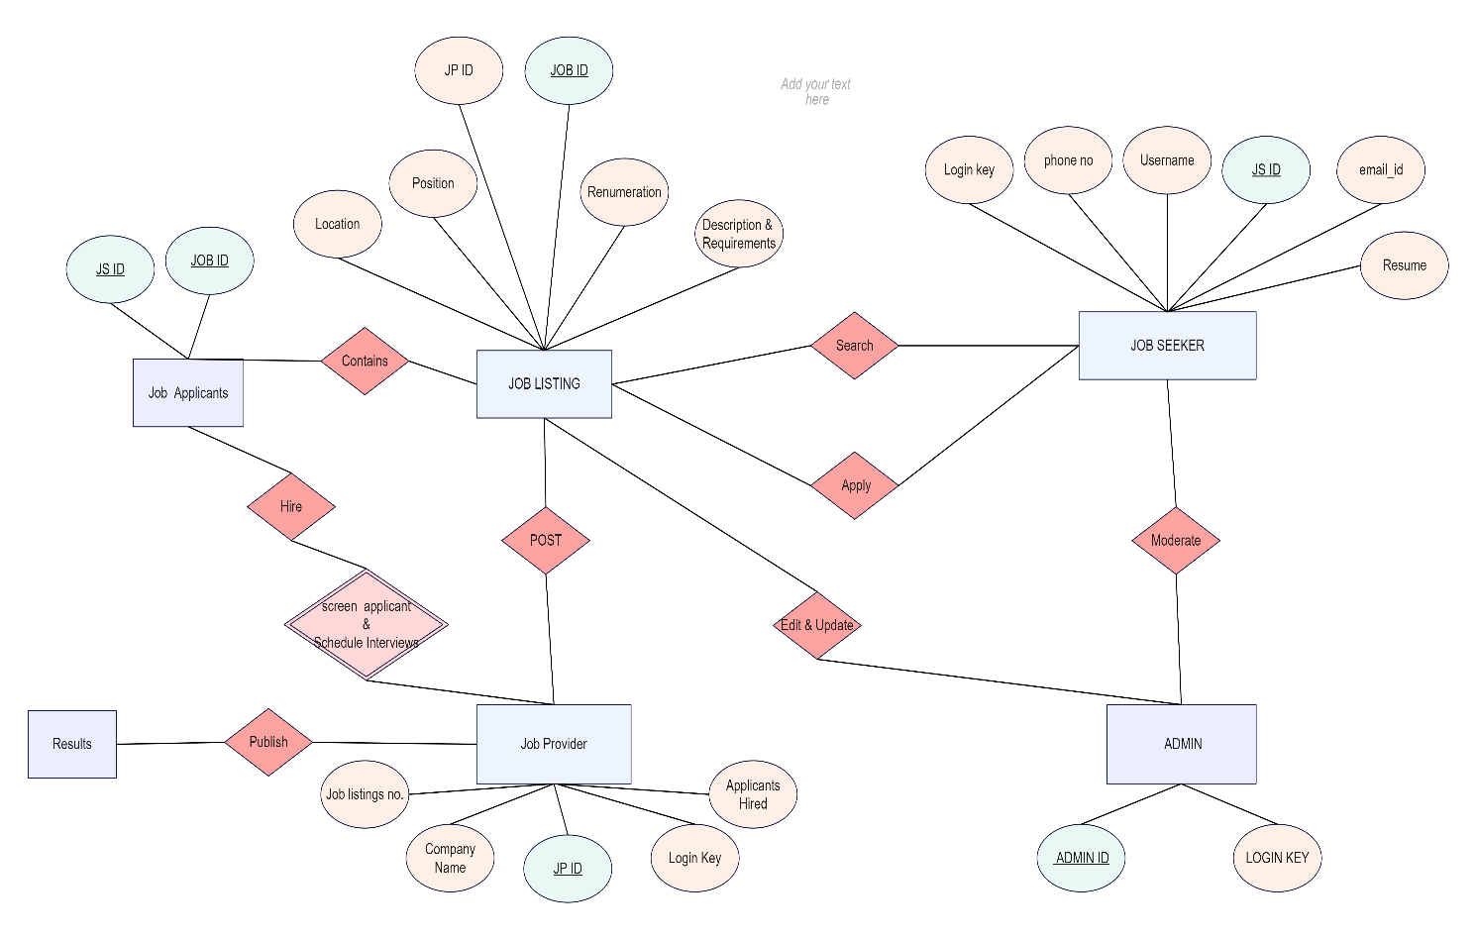

CLASS DIAGRAM

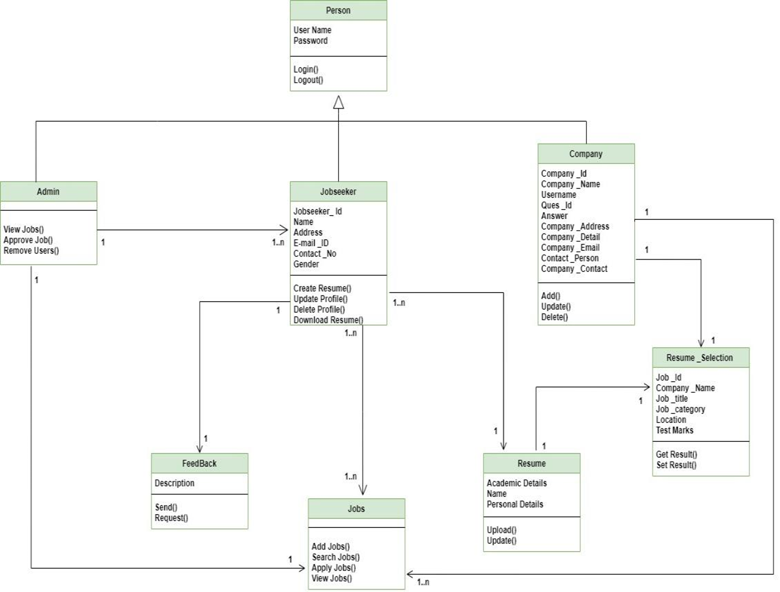

CREATED DATABASE

